Note to delete from the report: This design document should be no less than 10 pages. 10~15 pages is OK, 15-20 pages are also OK.

4413M W26 Team project report

Team composition
The description of our team is as follows:
- Team name: ….
- Team member 1’ s name and student id (in parenthesis): first name, last name, student id
- Team member 2’ s name and student id (in parenthesis): first name, last name, student id
- Team member 3’ s name and student id (in parenthesis): first name, last name, student id
- Team member 4’ s name and student id (in parenthesis): first name, last name, student id

Detail the individual contributions in one paragraph per member.
Also explain how each team member learned about elements of the projects done by other members.
Each member of the team signs the document to attest that team member contributions reflect the reality.

Table of content (feel free to add sub-sections)
1. Introduction
2. Architecture description
2.1 … (feel free to add sub-sections)
2.2 …
3. Design description
3.1 … (feel free to add sub-sections)
3.2 …

4. Advanced and distinguished features (beyond the basic requirements)
4.1 … (feel free to add sub-sections)
4.2 …
5. Implementation
5.1 … (feel free to add sub-sections)
5.2
6. Deployment efforts
7. Conclusion

Note to delete from the report: This design document should be around 10~15 pages, with 15-20 pages also OK

Introduction
Describe in a paragraph what the team project is about.
Explain briefly in a paragraph how you have used patterns and technologies to complete the team projects.
Describe in a paragraph the main strengths and weaknesses of your design and implementation.

Architecture description
This Architecture section gives a high-level overview of the application, in which the overall architecture, and different system components are present.
Describe the architecture patterns used (such as 3-tier architecture), and how your architecture has a clear separation between front and back-end.
Draw the architecture diagram to show the front and backend, main components, and the flow of the user business logic. (search online for examples of architecture diagrams. You don’t have to be very formal. Just draw an overview picture of your application)
Draw a couple of use cases using use case or sequence diagrams. Alternatively/otherwise, give textual description of some use cases, showing the flow of the business logic. (Search online for examples of use case diagrams and sequence diagrams. Also see some samples of diagram or textual description)

Design description
Here you give details of design decisions. Describe the design patterns you used in the project, including MVC and DAO. Also, explain the main design decisions and trade-offs.
Present the UML package/class diagram for main components, showing how different models are related. An example is shown below.
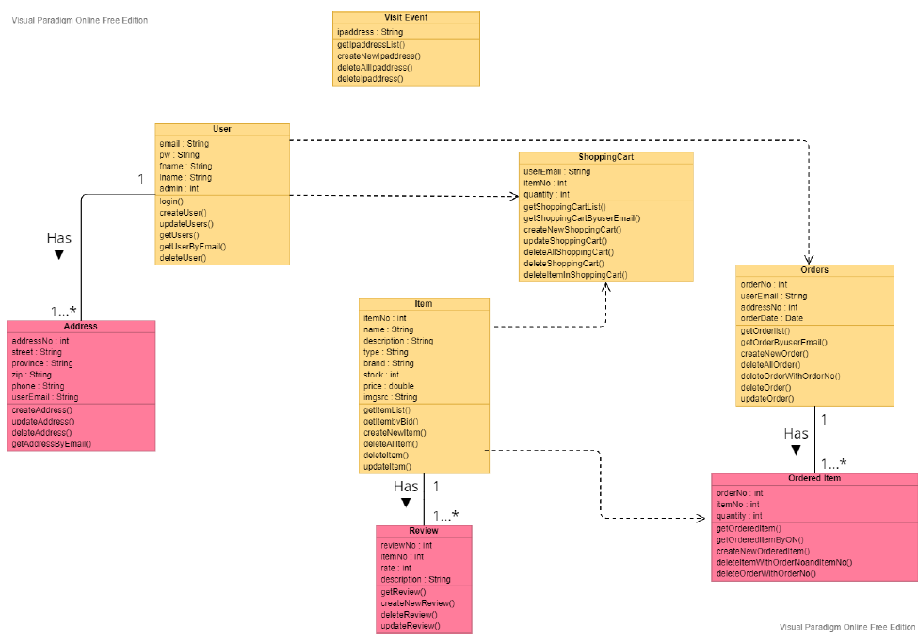
Also present the database schema diagrams showing the database tables you designed, and how different database tables are related.
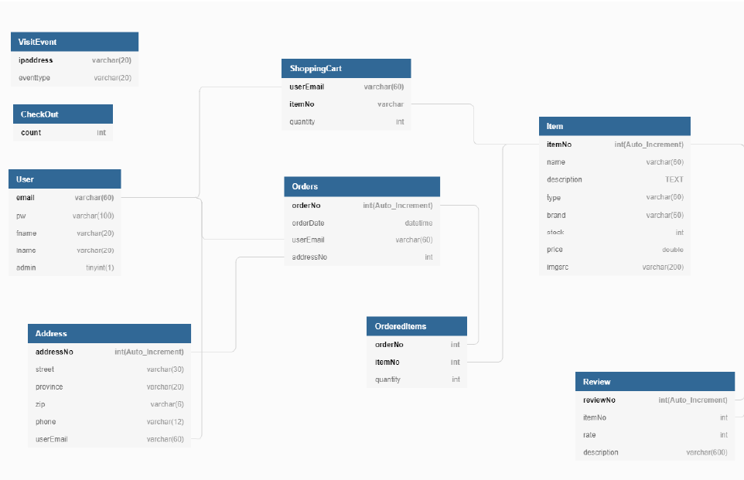

- Advanced and distinguished Features (Beyond the requirements)
Describe the features that are beyond the basic requirement (if any), as mentioned in the project pdf, for example,
- Use design patterns (in addition to MVC and DAO which are required), e.g,. Singleton, Factory, Observer, Façade etc
- Has one or more Web services that follow REST API (e.g., payment as a separate Web Service).
Customer:
- Product has inventory information (quantity remaining)
- Read and write reviews on items and rate items using five stars
- Ask questions to a live chatbot able to answer basic questions
- send confirmation email to customer after checkout.
- See their account page with customer info, purchase history etc…

Administrator:
- Can run a Reports on sales with option to save as disk file (e.g. as PDF files).
- Maintain customer account pages with customer info, purchase history etc
- Maintain inventory, to change quantity of product (add inventory)

Other creative/distinguished features you developed…
E.g., security concerns, prevent SQL injection etc..
….. other innovative features

Implementation
Here describe the implementation decisions, the trade-offs.
Specifically, describe the technologies that your team has considered and explored for front-end (e.g., HTML, React, Angular) and back-end (e.g., Servlet/JSP, Springboots, Node.js, Rail), and what are the trade-offs, and what is your final decision on the technologies for front-end and back-end, and justify your decision -- especially if you use technologies that are not covered in class, e.g., REACT, Angular, Springboots, Node.js), explaining why you decided to use them and what make them more favorable than Servlet/JSP covered in class.

Similarly, also describe the database systems you have explored and finally chose. Justify your decision.

Deployment efforts
Describe your efforts in finding a solution to the deployment of your project. Describe what you have tried to deploy the project, either online or to Docker, so other people can run your project.
If you are successful in deploying the project, describe your final choice, and how the project is deployed.
If you are not successful in deploying it, describe the problem you encountered.

Conclusion
- Summarize in a paragraph how you have used architecture and design patterns and technologies to complete the team projects.
- Summarize in a paragraph the main strengths and weaknesses of your design and implementation.
Also, Explain the following in your conclusion:
- What went well in the team project?
- What went wrong in the team project?
- What have you learned from the team project?
- What are the advantages and drawbacks of completing the project in teams?

